Web Link: https://scratch.mit.edu/

Project Link: https://scratch.mit.edu/projects/650889696

**Flying Parrot**

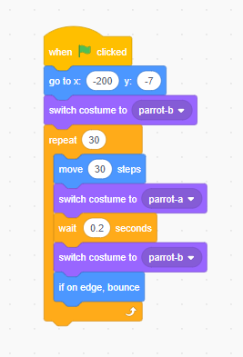When {Flag} Clicked ()

Go to x: (-200) y: (-7);

Switch costume to (parrot-b);

Repeat {(30)

{

Move {30} steps;

Switch costume to (parrot-a);

Wait (0.2) seconds;

Switch costume to (parrot-b);

If on edge, bounce;

};

};